**Detail**

**Design**

**Document**

**Table Design:**

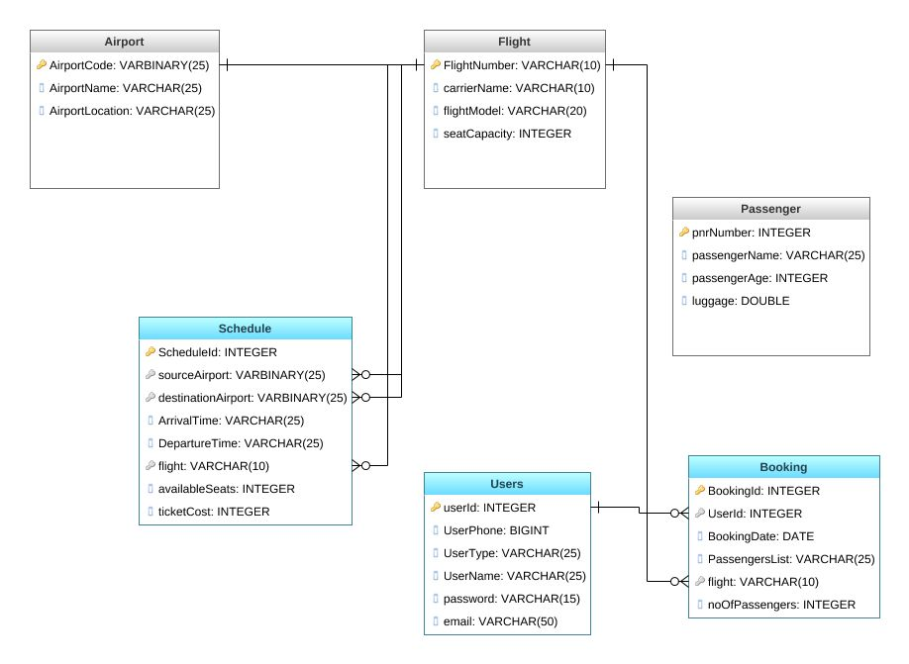

**ER Diagram:**

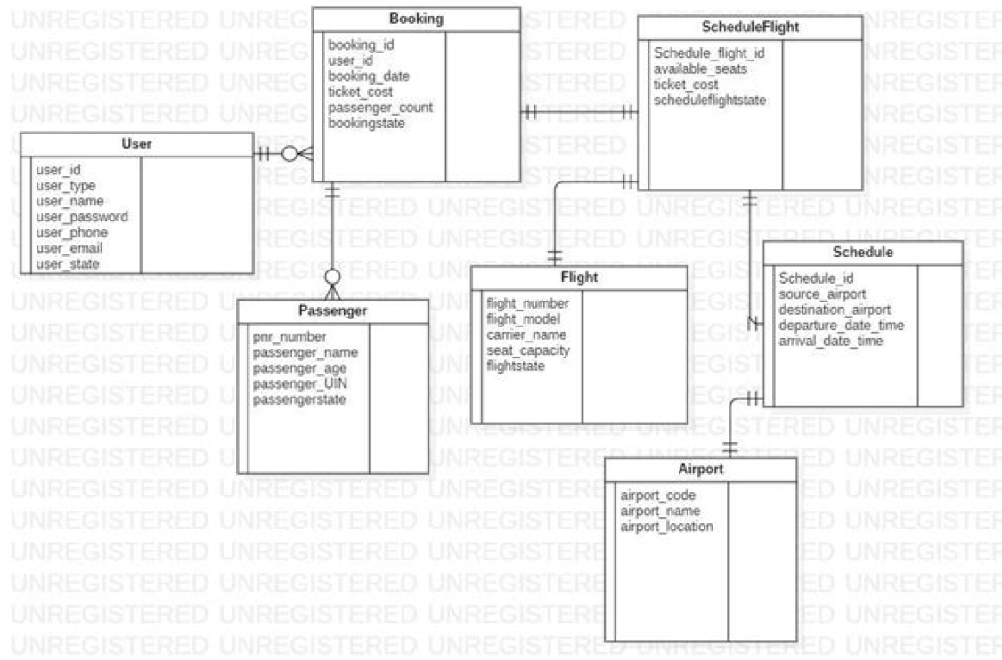

**Application Architecture:**

Flight Management System Is a Web Application which provide Users Sign-up page for Users Account.

Each User and Admin has a differed functionality. User login to his Account where he can Modify his user details like update user’s details, Delete user account and Search for Available Flights, from there he can process to Booking where the user can add the passenger details like name, age, gender and luggage etc. After booking User can modify the booking by Booking-Id and cancel his reservation too.

Admin can Schedule a Flight by adding the Source and Destination Airport with ticket Cost, date of Scheduling and the Seat capacity of Flight. Admin Can Search all the Available flights to Schedule a Flight, Admin can also Modify and delete the Scheduled Flight.

Flow of application:

Spring Dao

Spring service

Spring RestController

Angular Service

Angular Component

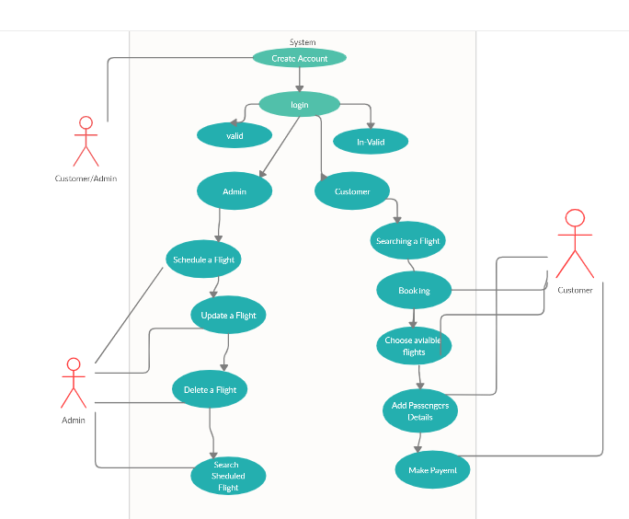

Use Case diagram for Flight-Management System

**Sequence Diagram for User:**

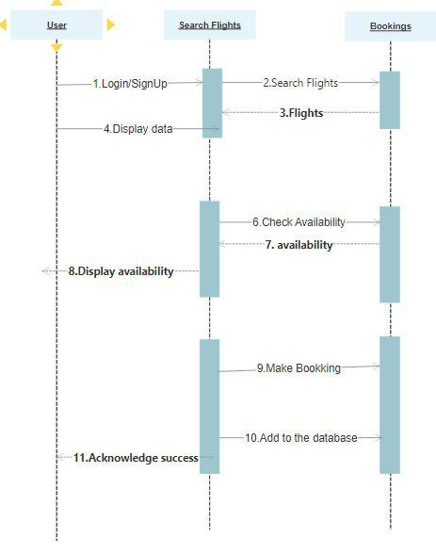

**Sequence Diagram for Admin:**

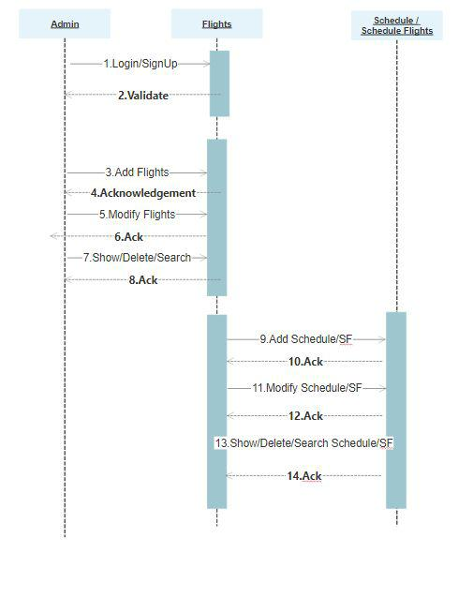

**Airpor**ts

.

.

.

.

.

.

.

.

.

.

.

.

.

.

.

.

.

.

.

.

.

.

.

.

.

.

.

.

.

.

.

--------------------15. Add Airport-------------->

🡨--------------**16.ACK**-------------

----------------17.Modify Airport----🡪

🡨--------------**18.ACK**---------------

19Show/Delete/Search Airport--🡪

🡨--------------**20.ACK**------------------

**Use Case Description:**

The main actors of flight management system in the Use case diagram are : User/Passenger, Admin/Airline Agency. who perform the different type of use cases such as manage Booking, managing Flight, managing Scheduled flight, managing Passengers and manage payments. And full flight management system operations.

* **Passenger/Customer** : Use cases of Customer are Login with valid credentials, Booking, Choosing Available Flights, Add Passenger, Make Payment.
* **Admin/Airline Agency** : Use cases of Admin are Schedule Flight, Update Flight, Delete Flight, Search Scheduled Flight and other full flight management system operations.



**Class Diagram :**

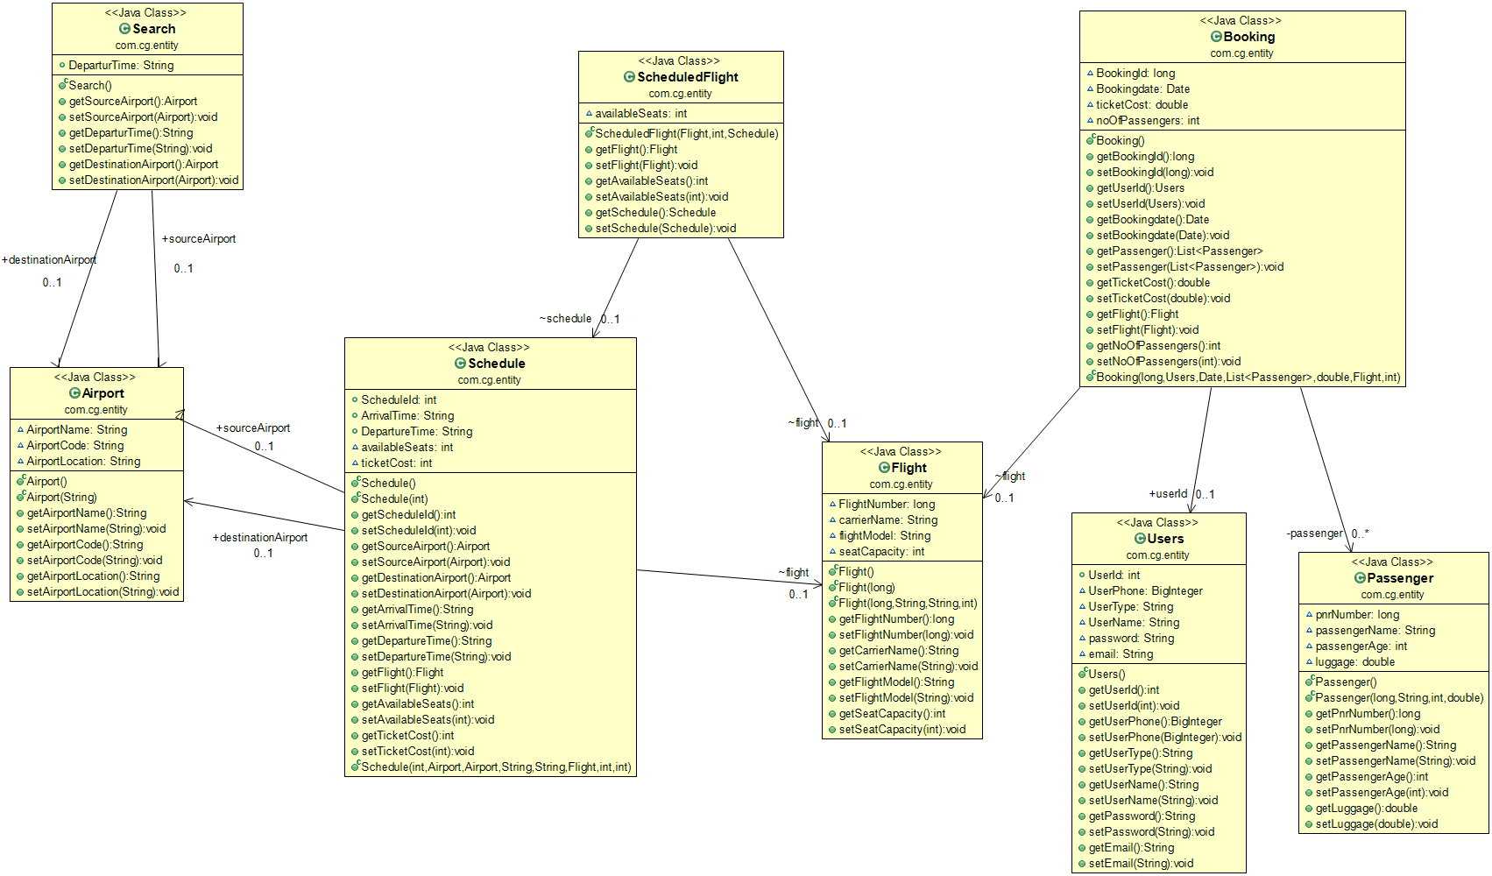

**WebServiceUrldetails**

**Flight**

**Get all flight.**

|  |  |
| --- | --- |
| URL | http://localhost:8090/api/getAllFlight |
| Method | getAllFlight() |
| Details | 1. By using this url we can get all the flight if the flights are available if it return status code 200 that means successful 2. If we enter anything wrong it will return status code 400 that means bad request. 3. If the flights are not available it will return status code 400 that means File Not Found |
| Returns | 200 Ok |
| 400 Bad Request |
| 404 Not Found |

**Get particular flight details by providing flight number of that flight.**

|  |  |
| --- | --- |
| URL | http://localhost:8090/api/getFlight |
| Method | getFlight() |
| Details | 1. By using this url we can get the particular flight details by entering flight number if it returns status code 200 that means successful   2. If we enter anything wrong it will return status code 400 that means bad request.  3. If the flight are not available with this flight number it will return status code 400 that means File Not Found |
| Returns | 200 Ok |
| 400 Bad Request |
| 404 Not Found |

**Add flight.**

|  |  |
| --- | --- |
| URL | http://localhost:8090/api/addFlight |
| Method | addFlight() |
| Details | 1. By using this url we can add new flight if the flight is added successfully it will return status code 200 that means successful 2. If we enter anything wrong it will return status code 400 that means bad request. |
| Returns | 200 Ok |
| 400 Bad Request |
|

**Update Flight.**

|  |  |
| --- | --- |
| URL | http://localhost:8090/api/updateFlight |
| Method | updateFlight() |
| Details | 1. By using this url we can update the particular flight details by entering flight number if it return status code 200 that means successful 2. If we enter anything wrong it will return status code 400 that means bad request. 3. If the flight are not available with this flight number it will return status code 400 that means File Not Found |
| Returns | 200 Ok |
| 400 Bad Request |
| 404 Not Found |

**DeleteFlight**

|  |  |
| --- | --- |
| URL | http://localhost:8090/api/deleteFlight |
| Method | deleteFlight() |
| Details | 1. By using this url we can delete the particular flight by entering flight number if it return status code 200 that means successful 2. If we enter anything wrong it will return status code 400 that means bad request. 3. If the flight are not available with this flight number it will return status code 400 that means File Not Found |
| Returns | 200 Ok |
| 400 Bad Request |
| 404 Not Found |

**Airport**

**Get all Airport.**

|  |  |
| --- | --- |
| URL | http://localhost:8060/airports |
| Method | getAllAirports() |
| Details | 1. By using this url we can get all the Airports if the airports are available if it return status code 200 that means successful 2. If we enter anything wrong it will return status code 400 that means bad request. 3. If the airports are not available it will return status code 400 that means File Not Found |
| Returns | 200 Ok |
| 400 Bad Request |
| 404 Not Found |

**Get particular Airport details by providing airport-code of that airport.**

|  |  |
| --- | --- |
| URL | http://localhost:8060/airport/airportCode |
| Method | getAirportByCode() |
| Details | 1. By using this url we can get the particular airport details by entering airport-code if it returns status code 200 that means successful 2. If we enter anything wrong it will return status code 400 that means bad request. 3. If the airport are not available with this airport code it will return status code 400 that means File Not Found |
| Returns | 200 Ok |
| 400 Bad Request |
| 404 Not Found |

**Add airport.**

|  |  |
| --- | --- |
| URL | http://localhost:8060/airport |
| Method | addAirport() |
| Details | 1. By using this url we can add new airport if the airport is added successfully it will return status code 200 that means successful 2. If we enter anything wrong it will return status code 400 that means bad request. |
| Returns | 200 Ok |
| 400 Bad Request |
|

**Update Airport.**

|  |  |
| --- | --- |
| URL | http://localhost:8060/update/airportCode |
| Method | updateAirport() |
| Details | 1. By using this url we can update the particular airport details by entering airport-code if it return status code 200 that means successful 2. If we enter anything wrong it will return status code 400 that means bad request. 3. If the airport are not available with this airport code it will return status code 400 that means File Not Found |
| Returns | 200 Ok |
| 400 Bad Request |
| 404 Not Found |

**DeleteAirport**

|  |  |
| --- | --- |
| URL | http://localhost:8060/delete/airportCode |
| Method | deleteAirport() |
| Details | 1. By using this url we can delete the particular airport by entering airport-code if it return status code 200 that means successful 2. If we enter anything wrong it will return status code 400 that means bad request. 3. If the airport are not available with this airport code it will return status code 400 that means File Not Found |
| Returns | 200 Ok |
| 400 Bad Request |
| 404 Not Found |

**Schedule**

**Display all airport-code.**

|  |  |
| --- | --- |
| URL | http://localhost:4200/viewAirportCode |
| Method | displayAirport() |
| Details | 1. By using this url we can get the list of all airport-code if the airport-code are available if it return status code 200 that means successful 2. If we enter anything wrong it will return status code 400 that means bad request. 3. If the airport codes are not available it will return status code 400 that means File Not Found |
| Returns | 200 Ok |
| 400 Bad Request |
| 404 Not Found |

**Display all flight-number.**

|  |  |
| --- | --- |
| URL | http://localhost:4200/viewFlightNum |
| Method | displayFlight() |
| Details | 1. By using this url we can get the list of all flight-number if the flight numbers are available if it return status code 200 that means successful 2. If we enter anything wrong it will return status code 400 that means bad request. 3. If the flight numbers are not available it will return status code 400 that means File Not Found |
| Returns | 200 Ok |
| 400 Bad Request |
| 404 Not Found |

**To search particular scheduled flight details by providing flight number**

|  |  |
| --- | --- |
| URL | http://localhost:4200/search |
| Method | search() |
| Details | 1. By using this url we can get the particular scheduled flight details by entering flight number if it returns status code 200 that means successful 2. If we enter anything wrong it will return status code 400 that means bad request. 3. If the flight are not available with this flight number it will return status code 400 that means File Not Found |
| Returns | 200 Ok |
| 400 Bad Request |
| 404 Not Found |

**Add Schedule of Flight.**

|  |  |
| --- | --- |
| URL | http://localhost:4200/addSchedule |
| Method | adding() |
| Details | 1. By using this url we can add new schedule of flight if the schedule is added successfully it will return status code 200 that means successful 2. If we enter anything wrong it will return status code 400 that means bad request. |
| Returns | 200 Ok |
| 400 Bad Request |
|

**Update the particular scheduled Flight.**

|  |  |
| --- | --- |
| URL | http://localhost:4200/update |
| Method | update() |
| Details | 1. By using this url we can update the particular scheduled flight details by entering flight number if it return status code 200 that means successful 2. If we enter anything wrong it will return status code 400 that means bad request. 3. If the flight are not available with this flight number it will return status code 400 that means File Not Found |
| Returns | 200 Ok |
| 400 Bad Request |
| 404 Not Found |

**Delete Flight.**

|  |  |
| --- | --- |
| URL | http://localhost:4200/delete |
| Method | delete() |
| Details | 1. By using this url we can delete the particular scheduled flight by entering flight number if it return status code 200 that means successful 2. If we enter anything wrong it will return status code 400 that means bad request. 3. If the flight are not available with this flight number it will return status code 400 that means File Not Found |
| Returns | 200 Ok |
| 400 Bad Request |
| 404 Not Found |

**Display all scheduled id.**

|  |  |
| --- | --- |
| URL | http://localhost:4200/viewScheduleIds |
| Method | displayScheduleids() |
| Details | 1. By using this url we can get the list of all scheduled ids if the ids are available if it return status code 200 that means successful 2. If we enter anything wrong it will return status code 400 that means bad request. 3. If ids are not available it will return status code 400 that means File Not Found |
| Returns | 200 Ok |
| 400 Bad Request |
| 404 Not Found |

**Display all scheduled flights.**

|  |  |
| --- | --- |
| URL | http://localhost:4200/viewAllSchedule |
| Method | displayAllSchedule() |
| Details | 1. By using this url we can get the list of all scheduled flights if the flights are available if it return status code 200 that means successful 2. If we enter anything wrong it will return status code 400 that means bad request. 3. If flights are not available it will return status code 400 that means File Not Found |
| Returns | 200 Ok |
| 400 Bad Request |
| 404 Not Found |

**Booking**

**Get list of all booking.**

|  |  |
| --- | --- |
| URL | http://localhost:1111/viewBooking |
| Method | viewBooking() |
| Details | 1. By using this url we can get the list of all booking if the bookings are available if it return status code 200 that means successful 2. If we enter anything wrong it will return status code 400 that means bad request. 3. If the bookings are not available it will return status code 400 that means File Not Found |
| Returns | 200 Ok |
| 400 Bad Request |
| 404 Not Found |

**Get particular booking details by providing id.**

|  |  |
| --- | --- |
| URL | http://localhost:1111/api/viewBooking/{id} |
| Method | viewBooking() |
| Details | 1. By using this url we can get the particular booking details by entering booking id if it returns status code 200 that means successful 2. If we enter anything wrong it will return status code 400 that means bad request. 3. If the booking are not available with this booking id it will return status code 400 that means File Not Found |
| Returns | 200 Ok |
| 400 Bad Request |
| 404 Not Found |

**Do booking.**

|  |  |
| --- | --- |
| URL | http://localhost:1111/api/addBooking |
| Method | addBooking() |
| Details | 1. By using this url we can do new booking if the booking is done successfully it will return status code 200 that means successful 2. If we enter anything wrong it will return status code 400 that means bad request. |
| Returns | 200 Ok |
| 400 Bad Request |
|

**Cancel Booking**

|  |  |
| --- | --- |
| URL | http://localhost:1111/cancelBooking/{id} |
| Method | cancelBooking() |
| Details | 1. By using this url we can cancel the particular booking by entering booking id if it return status code 200 that means successful 2. If we enter anything wrong it will return status code 400 that means bad request. 3. If the booking are not available with this booking id it will return status code 400 that means File Not Found |
| Returns | 200 Ok |
| 400 Bad Request |
| 404 Not Found |

**Users**

**Get list of all users.**

|  |  |
| --- | --- |
| URL | http://localhost:1130/api/getUser |
| Method | getAllUsers() |
| Details | 1. By using this url we can get all the users if the users are available if it return status code 200 that means successful 2. If we enter anything wrong it will return status code 400 that means bad request. 3. If the users are not available it will return status code 400 that means File Not Found |
| Returns | 200 Ok |
| 400 Bad Request |
| 404 Not Found |

**Get particular user details by providing user id.**

|  |  |
| --- | --- |
| URL | http://localhost:1130/viewbyid{id} |
| Method | viewBooking() |
| Details | 1. By using this url we can get the particular user details by entering user id if it returns status code 200 that means successful 2. If we enter anything wrong it will return status code 400 that means bad request. 3. If the user are not available with this user id it will return status code 400 that means File Not Found |
| Returns | 200 Ok |
| 400 Bad Request |
| 404 Not Found |

**Add User.**

|  |  |
| --- | --- |
| URL | http://localhost:1130/addUser |
| Method | addUser() |
| Details | 1. By using this url we can add new user if the user is added successfully it will return status code 200 that means successful 2. If we enter anything wrong it will return status code 400 that means bad request. |
| Returns | 200 Ok |
| 400 Bad Request |
|

**Update user.**

|  |  |
| --- | --- |
| URL | http://localhost:1130/updateuser{id} |
| Method | Updateuser() |
| Details | 1. By using this url we can update the particular user details by providing user id if it return status code 200 that means successful 2. If we enter anything wrong it will return status code 400 that means bad request. 3. If the user are not available with this user id it will return status code 400 that means File Not Found |
| Returns | 200 Ok |
| 400 Bad Request |
| 404 Not Found |

**Delete User**

|  |  |
| --- | --- |
| URL | http://localhost:1130/deleteUser{id} |
| Method | cancelBooking() |
| Details | 1. By using this url we can delete the particular user by providing user id if it return status code 200 that means successful 2. If we enter anything wrong it will return status code 400 that means bad request. 3. If the user are not available with this user id it will return status code 400 that means File Not Found |
| Returns | 200 Ok |
| 400 Bad Request |
| 404 Not Found |

**Get list of all available flights.**

|  |  |
| --- | --- |
| URL | http://localhost:1130/search |
| Method | search() |
| Details | 1. By using this url we can get all the flights if the fllights are available if it return status code 200 that means successful 2. If we enter anything wrong it will return status code 400 that means bad request. 3. If the flights are not available it will return status code 400 that means File Not Found |
| Returns | 200 Ok |
| 400 Bad Request |
| 404 Not Found |

**Login User**

|  |  |
| --- | --- |
| URL | http://localhost:1130/userLogin |
| Method | UserLogin() |
| Details | 1. By using this url the user can login to his account by providing username and password if it return status code 200 that means successful 2. If we enter anything wrong it will return status code 400 that means bad request. 3. If the username and password either of one are not correct it will return status code 400 that means File Not Found |
| Returns | 200 Ok |
| 400 Bad Request |
| 404 Not Found |